- Take example web site www.shipchandlerabidjanport.com

On the web site description only for SHIP CHANDLER service. NOT LOGISTIC, NOT DELIVERY CARGO. Only food provision, food store, ship chandlers, ship supply, vessel supply, bond store supply, drinks and snacks supply. It is key words.

EACH DOMAIN SHOULD BE INCLUDE THIS PORTS SERVICE HOW BELOW ON THE SCREENSHORT:

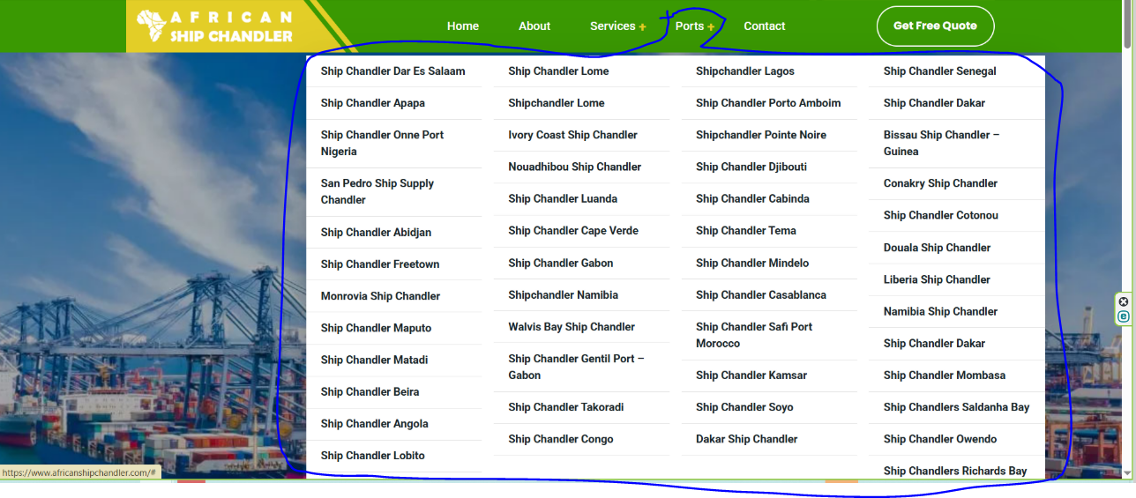

- Need full description of ship chandler in Abidjan port.
(USE BELOW TEMPLATE for all 42 domains, just change name of port and some description use CHATGPT.)

Ship Chandler in Abidjan Port, Côte d’Ivoire
Ship Chandler Abidjan Port provides comprehensive ship supply and marine procurement services for vessels calling at the Port of Abidjan, Côte d’Ivoire. We support ship owners, ship managers, purchasing departments, technical superintendents, captains and local agents with reliable vessel supplies and coordinated delivery directly to vessels during their port stay.
Our objective is to provide a single point of contact for all vessel requirements in Abidjan. From fresh provisions and bonded stores to deck, engine and technical supplies, our team coordinates each order according to the vessel’s ETA, berth, operational schedule and individual requisition.

Ship Supply Services in Abidjan
We supply a complete range of marine stores for merchant vessels, including:

Provisions
We supply fresh, chilled, frozen and dry provisions for vessel crews and galley operations, including:
- Fresh fruits and vegetables
- Meat and poultry
- Fresh and frozen seafood
- Dairy products
- Eggs
- Bakery products
- Rice, pasta, flour and cereals
- Canned products
- Frozen food
- Dry provisions
- Beverages and drinking water
- Juices and soft drinks
- Coffee and tea
- Condiments, spices and sauces
- International and local food products
- Special dietary products upon request
Orders can be prepared according to crew nationality, vessel requirements and requested brands or pack sizes.

Bonded Stores
Bonded and duty-free stores can be supplied subject to applicable customs and port regulations.
Our range may include:
- Tobacco products
- Confectionery
- Soft drinks
- Personal care products
- Crew welfare items
- Other bonded products requested by the vessel

Deck Stores
Our deck department can source and supply a wide range of deck consumables and equipment, including:
- Mooring ropes and hawsers
- Wire ropes
- Shackles
- Turnbuckles
- Chains
- Lifting accessories
- Cargo securing materials
- Hoses and couplings
- Marine paints and coatings
- Brushes and rollers
- Tarpaulins
- Cleaning equipment
- Deck maintenance tools
- Safety signs
- Marine hardware
- Hand tools
- PPE and working equipment
Products can be quoted according to IMPA references, dimensions, SWL, material specifications, required certificates or preferred manufacturers.

Engine Stores
We support engine departments with routine consumables, tools and technical materials such as:
- Filters
- Gaskets
- Bearings
- Valves
- Pumps
- Mechanical seals
- Lubricants and greases
- Hydraulic hoses and fittings
- Hydraulic products
- Measuring instruments
- Hand and power tools
- Workshop consumables
- Fasteners
- Electrical materials
- Welding consumables
- Engine-room cleaning chemicals
- Pipes, fittings and flanges
- Selected machinery spare parts
For technical requirements, customers are encouraged to provide maker, model, serial number, part number, drawings or photographs to ensure accurate sourcing.

Cabin & Galley Stores
We provide everyday consumables and equipment required by the accommodation and catering departments, including:
- Bed linen
- Towels
- Blankets
- Mattresses and pillows
- Tableware
- Cookware
- Kitchen utensils
- Galley equipment
- Cleaning products
- Laundry products
- Toiletries
- Garbage bags
- Cabin consumables
- Crew welfare products

Safety Equipment & PPE
Safety and personal protective equipment can be supplied according to vessel requirements, including:
- Safety helmets
- Safety shoes
- Coveralls
- Protective gloves
- Safety goggles
- Face shields
- Respiratory protection
- Safety harnesses
- Life-saving equipment
- Fire-fighting related products
- Safety signs and tapes
- First-aid products
Where certification is required, the applicable standard or certificate requirement should be specified in the RFQ.

Electrical Stores
We source electrical products and consumables for deck, engine-room and accommodation requirements, including:
- Marine lamps
- LED lighting
- Cables and wires
- Plugs and sockets
- Circuit breakers
- Fuses
- Contactors
- Relays
- Switches
- Batteries
- Electrical tools
- Cable accessories
- Electrical consumables

Marine Chemicals
Marine and industrial chemicals can be supplied for vessel maintenance and operational requirements, including:
- Cleaning chemicals
- Degreasers
- Rust removers
- Descaling chemicals
- Tank cleaning products
- Water-treatment chemicals
- Maintenance chemicals
- Engine-room cleaning products
Product specifications and Safety Data Sheets can be provided where applicable.

Welding Equipment & Consumables
We can source:
- Welding electrodes
- Welding wire
- Cutting discs
- Grinding discs
- Welding accessories
- Welding PPE
- Regulators
- Hoses
- Cutting and welding equipment
- Industrial and marine gases subject to local availability and regulations

Marine Spare Parts & Technical Procurement
Our procurement team can assist with standard and non-standard marine spare parts and technical equipment.
Requests may include:
- Main and auxiliary engine parts
- Pump components
- Compressor parts
- Electric motors
- Refrigeration components
- Navigation equipment
- Communication equipment
- Marine electronics
- Electrical components
- Hydraulic components
- Industrial equipment
- OEM and alternative spare parts
For faster identification, please provide maker, equipment model, serial number, OEM part number, IMPA reference, dimensions, drawings or clear photographs.

Nautical Charts & Publications
Subject to availability, we can assist vessels with nautical and marine publications required for their voyage and operation.

Tools & Marine Hardware
Our supply range includes hand tools, power tools, cutting tools, measuring equipment, fasteners and general marine hardware for routine maintenance and emergency repairs.

Urgent Ship Supply in Abidjan
Vessel schedules can change quickly. For urgent requirements, our team can coordinate procurement and delivery according to the vessel’s ETA, berth availability, port access and local operating conditions.
Urgent enquiries should clearly indicate the required delivery deadline so that availability and logistics can be assessed immediately.

Vessels We Support
Our ship chandling services are suitable for a wide range of commercial vessels calling at Abidjan, including:
- Bulk carriers
- Container vessels
- General cargo vessels
- Oil tankers
- Chemical tankers
- LPG and LNG carriers
- Ro-Ro vessels
- Reefer vessels
- Offshore support vessels
- Tugs and workboats
- Fishing vessels
- Passenger vessels
- Project cargo vessels
- Other merchant and commercial ships

Supply Coordination at Port of Abidjan
Every vessel order is coordinated around the actual port call.
To prepare an accurate quotation, please provide:
- Vessel name
- IMO number
- Vessel type
- Port of delivery: Abidjan
- ETA
- Berth or terminal, if known
- Required delivery date and time
- Complete requisition list
- Required quantities
- Preferred brands
- IMPA or ISSA references
- Maker and part numbers for technical items
- Photographs or drawings where necessary
Requisitions may be submitted in Excel, PDF, Word or other commonly used formats.

Why Choose Ship Chandler Abidjan Port?
Our approach is based on fast communication, competitive sourcing and careful coordination with the vessel’s operational schedule.
We aim to provide:
- One point of contact for multiple supply categories
- Fast response to RFQs
- Competitive quotations
- Local procurement and sourcing
- International marine product sourcing
- Provision and technical supply in one order
- Support for urgent requirements
- Clear communication with vessel and purchasing departments
- Delivery coordination according to vessel ETA and berth
- Support for IMPA and specification-based requisitions

Request a Quotation
For ship supply requirements at the Port of Abidjan, send us your vessel details, ETA and complete requisition list.
Our supply team can review requirements for provisions, bonded stores, cabin and galley stores, deck stores, engine stores, electrical supplies, safety equipment, marine chemicals, tools, spare parts and technical marine equipment.
SHIP CHANDLER ABIDJAN PORT
Port of Abidjan
Côte d’Ivoire
24/7 Vessel Supply & Marine Procurement
Send your RFQ before the vessel’s arrival whenever possible to allow sufficient time for sourcing, quotation and delivery coordination.

